Issue 1: S5261: Add explicit curly braces to avoid dangling else

* **Type:** Code Smell
* **Cause:** The issue arises when nested if/else statements are written without curly braces. This can lead to confusion as the "else" statement is associated with the nearest "if" statement, but this is not always obvious. The lack of explicit curly braces can make the code difficult to understand
* **Level:** Major
* **Image before fix:**

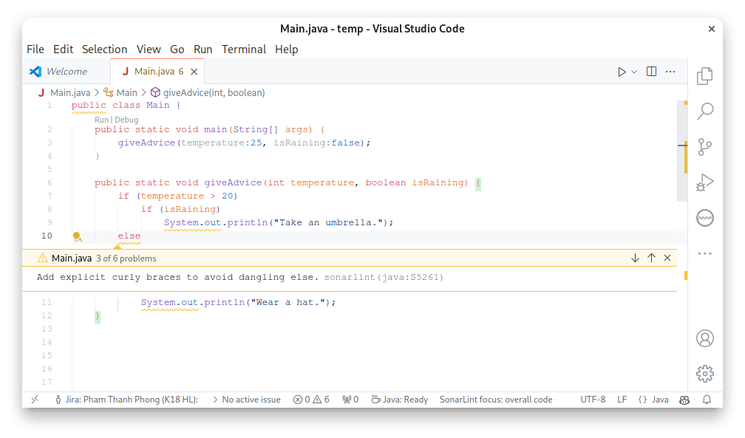

* **Image after fix:**

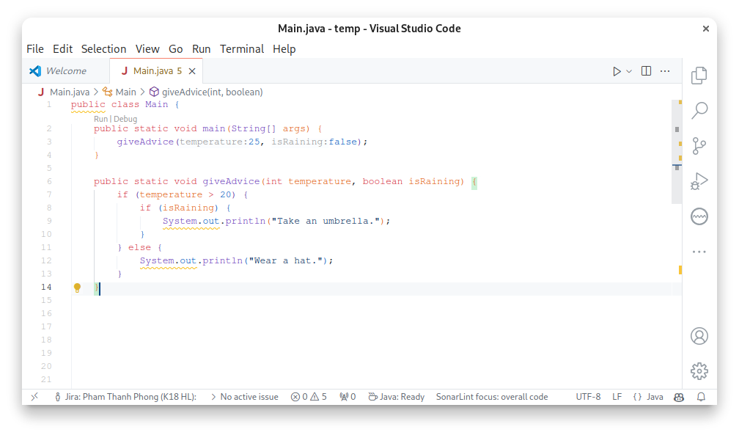

Issue 2: S108: Nested blocks of code should not be left empty

* **Type:** Code Smell
* **Cause:** The issue arises when a block of code is left empty. This can lead to confusion as it is unclear whether the block is intentionally empty or if the implementation is incomplete.
* **Level:** Major
* **Image before fix:**

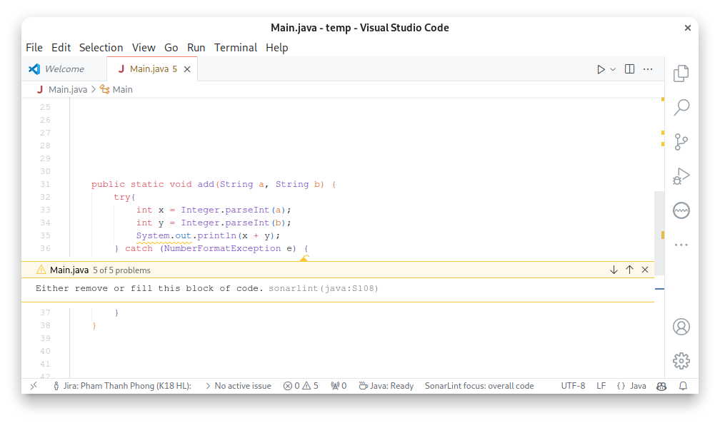

* **Image after fix:**

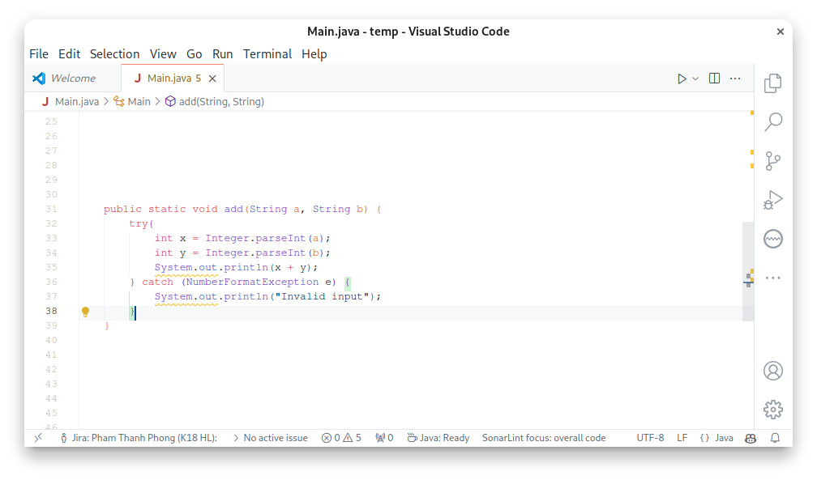

Issue 3: S1201: "equals" method overrides should accept "Object" parameters

* **Type:** Bug
* **Cause:** The issue arises when the "equals" method does not accept an "Object" parameter. This can lead to confusion as the "equals" method should be used exclusively to override Object.equals(Object).
* **Level:** Major
* **Image before fix:**

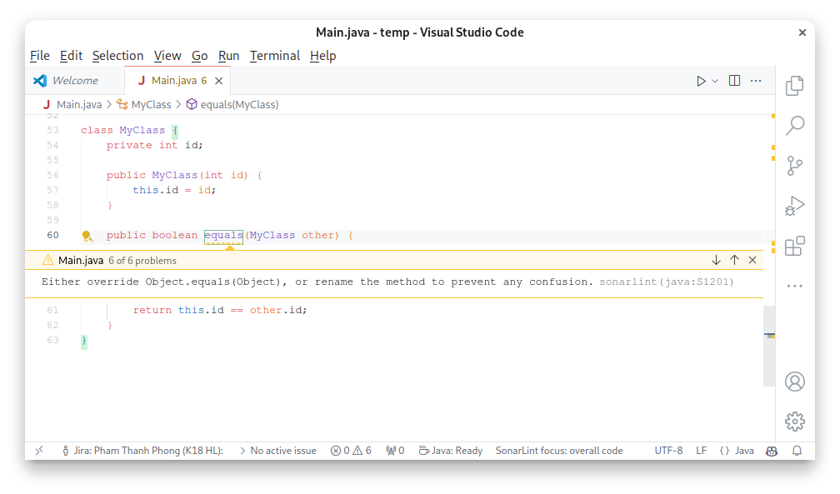

* **Image after fix:**

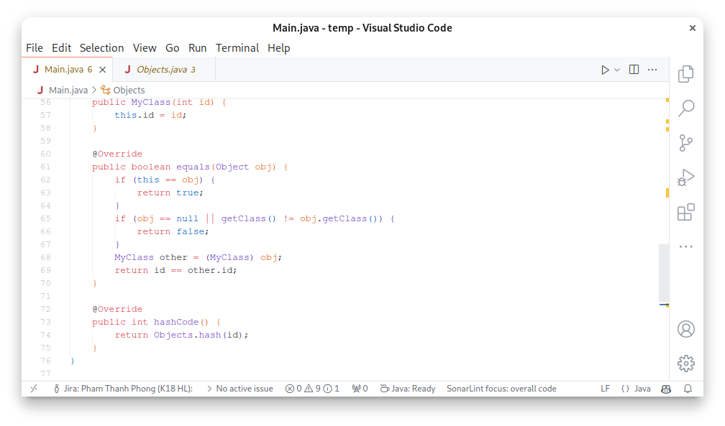

Issue 4: S4351: "compareTo" should not be overloaded

* **Type**: Bug
* **Cause:** The issue arises when the compareTo method of a class implementing Comparable<T> is not the same as the one used in the Comparable declaration. This creates an overload instead of an override, which is unlikely to be the intent
* **Level:** Major
* **Image before fix:**

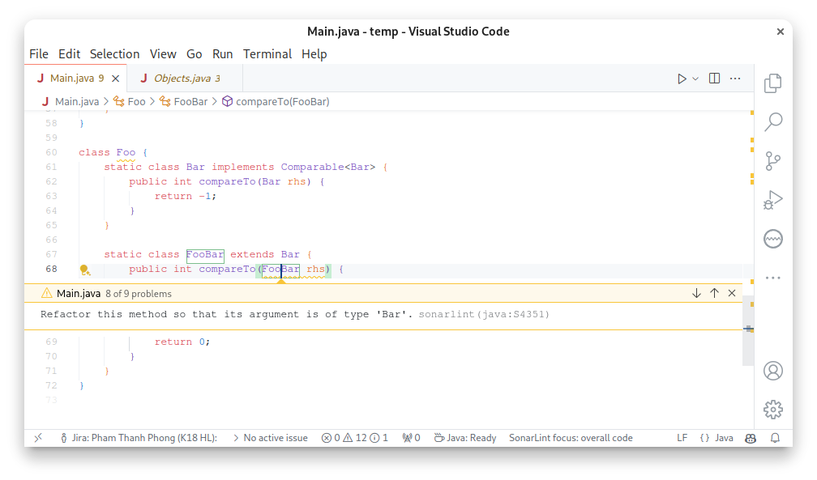

* **Image after fix:**

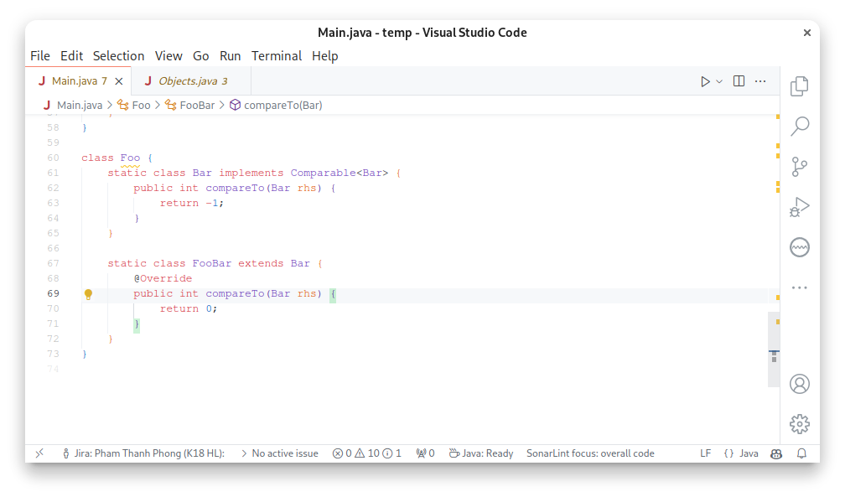

Issue 5: S4087: "close()" calls should not be redundant

* **Type:** Code Smell
* **Cause:** The issue arises when the close() method is called explicitly in a try-with-resources structure. This is redundant because the try-with-resources structure automatically handles closing the resources that the try itself opens
* **Level:** Minor
* **Image before fix:**

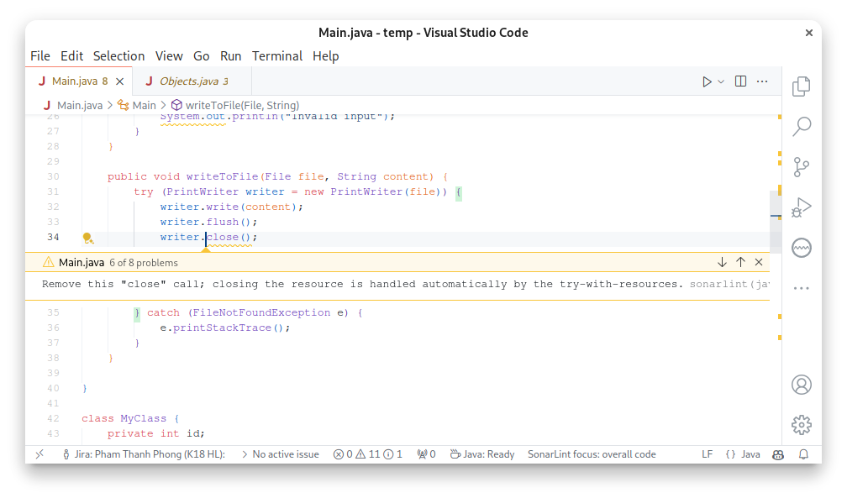

* **Image after fix:**

